Multi Threading:

Task01:  
what is **process ?**   
--- it is a combination of multiple threads, where each thread has its own separate task to execute. These threads run one by one within fractions of a millisecond as part of the process execution.

Example :WhatsApp – one thread is responsible for sending message , one thread us responsible for receiving , another for notification and one more download and so on……..

Task02:

What is thread?

Thread is small unit of process.  
-- thread are very very light weighted means it will occupy less memory to store.

Task03: implements threading

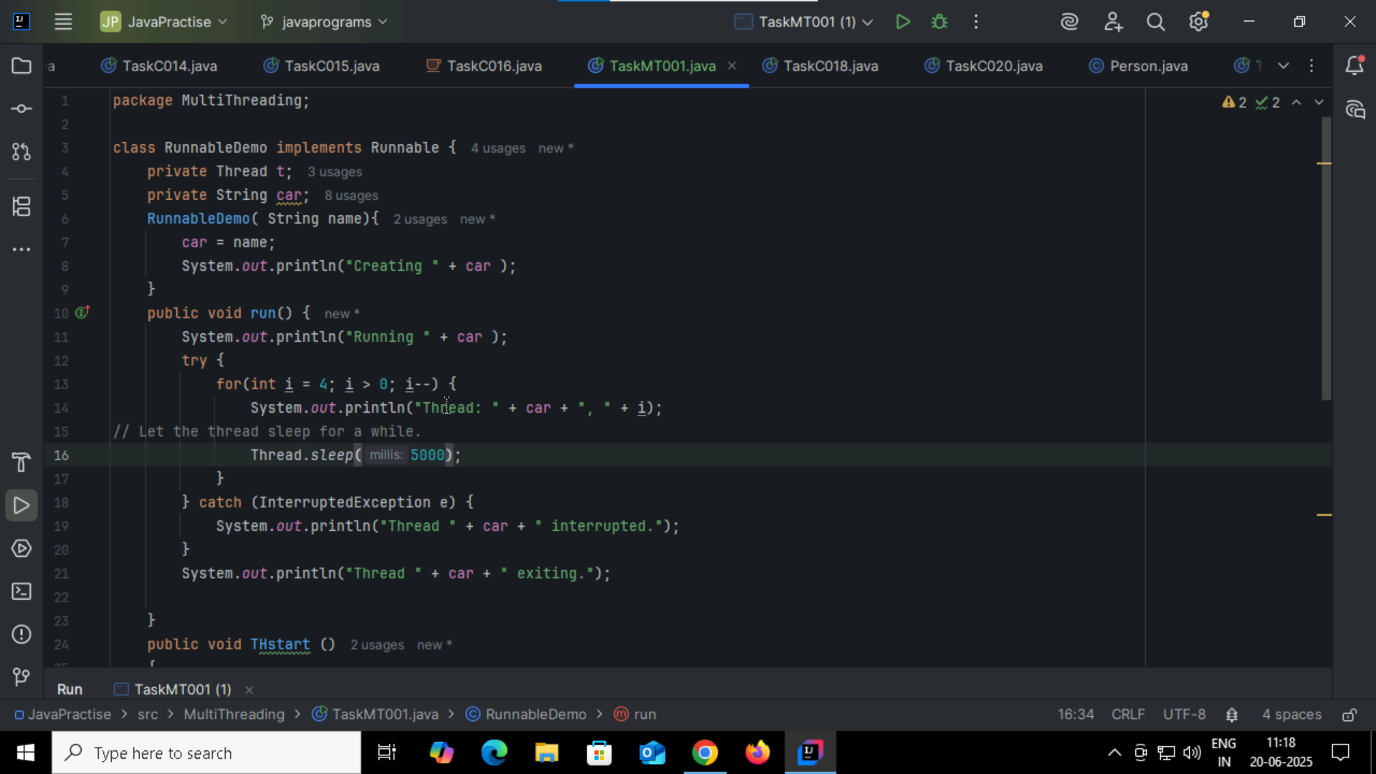

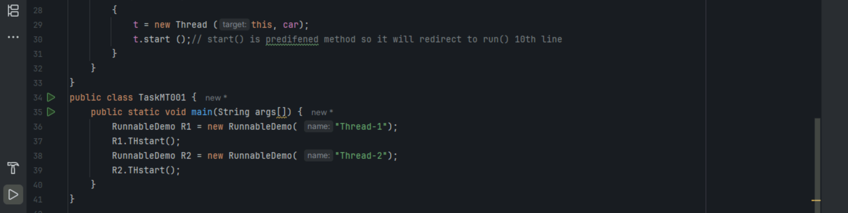

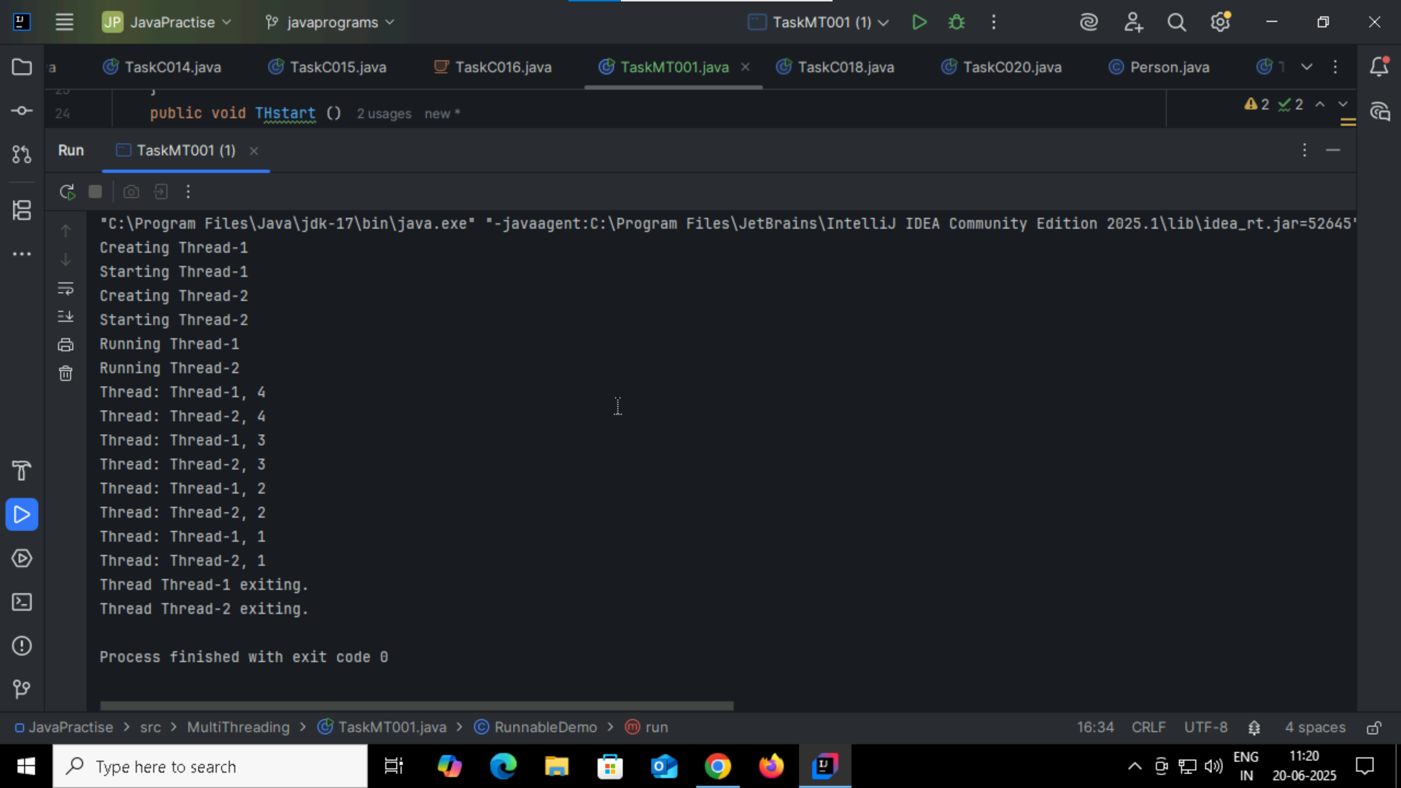

Task004: extends multiThraeding  
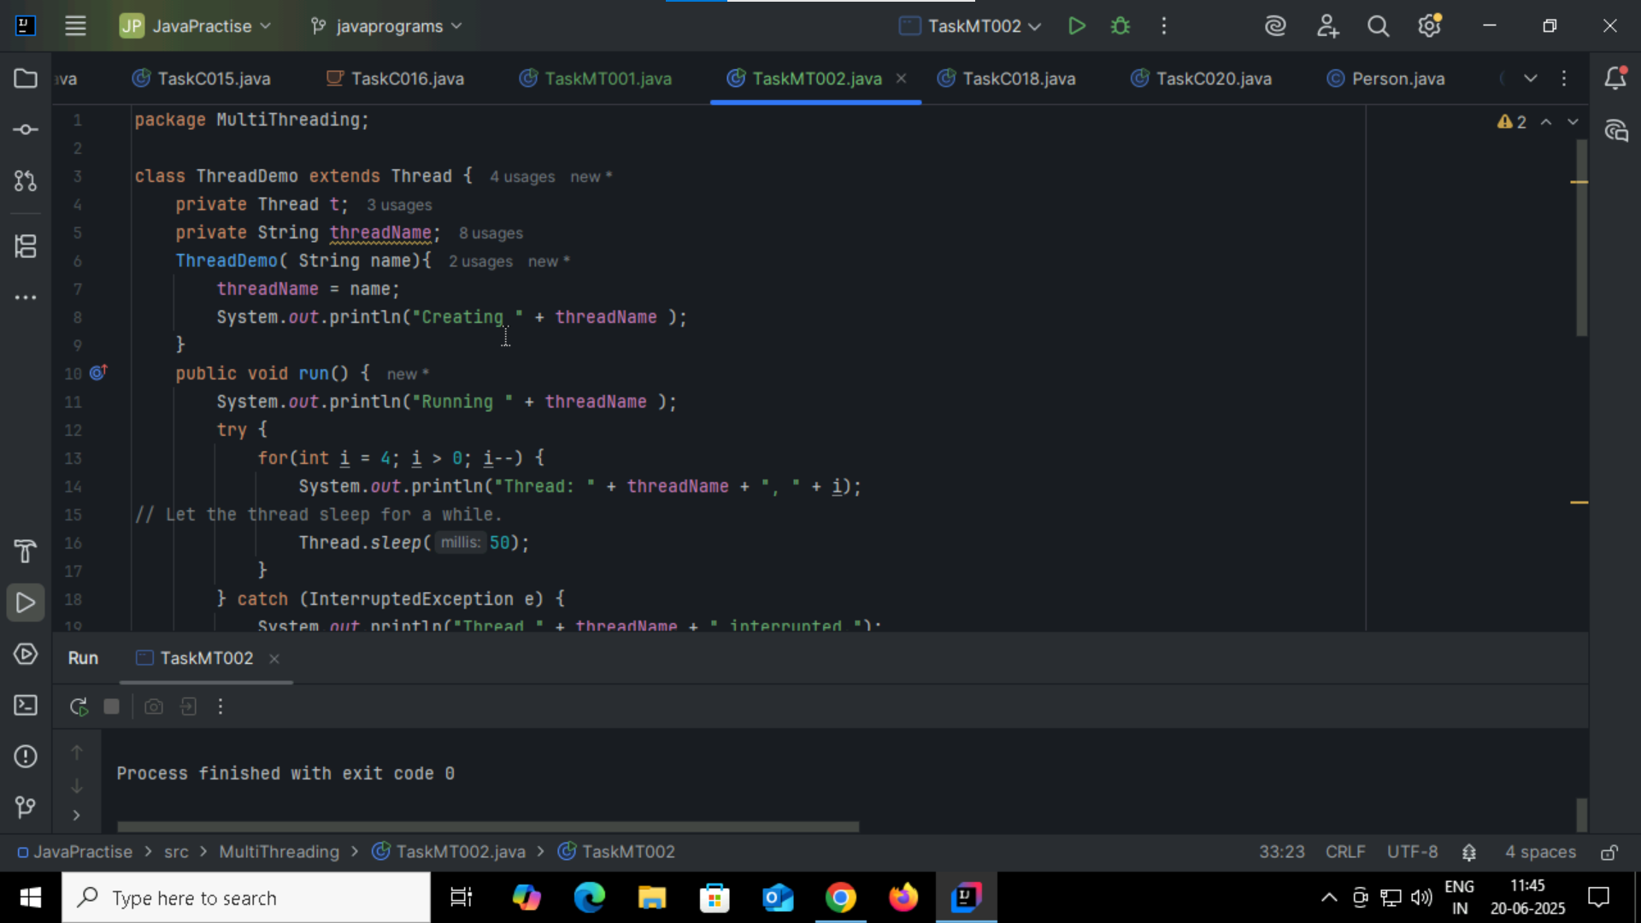

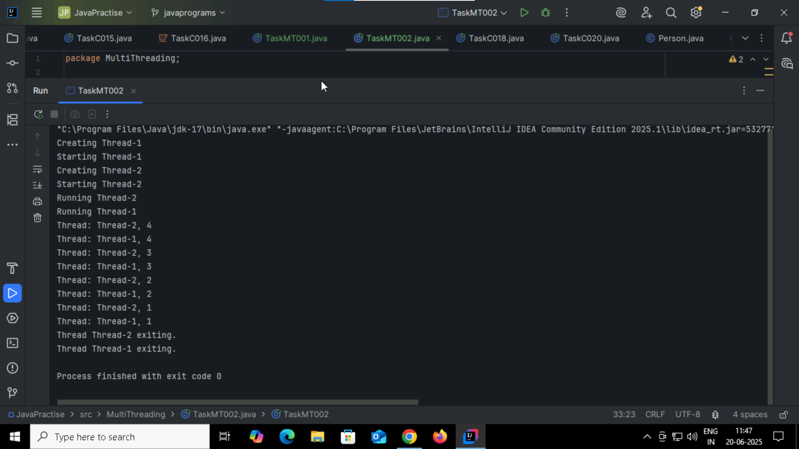

Thread methods:

| **Method** | **Description** |
| --- | --- |
| start() | Starts a new thread and calls its run() method |
| run() | Contains the code to be executed by the thread |
| sleep(ms) | Pauses thread for given milliseconds |
| join() | Waits for a thread to finish before continuing |
| isAlive() | Checks if thread is still running |
| setName(String) | Sets thread's name |
| getName() | Returns thread's name |
| setPriority(int) | Sets thread's priority (1 to 10) |
| getPriority() | Returns thread’s priority |
| interrupt() | Interrupts a sleeping or waiting thread |
| isInterrupted() | Checks if thread has been interrupted |
| yield() | Suggests the current thread to pause and let others run |
| currentThread() | Returns reference to the currently running thread |
|  |  |

Task005: without synchronised

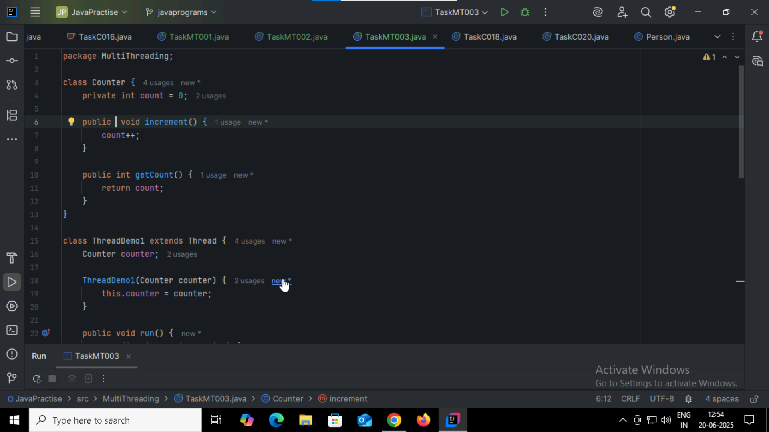

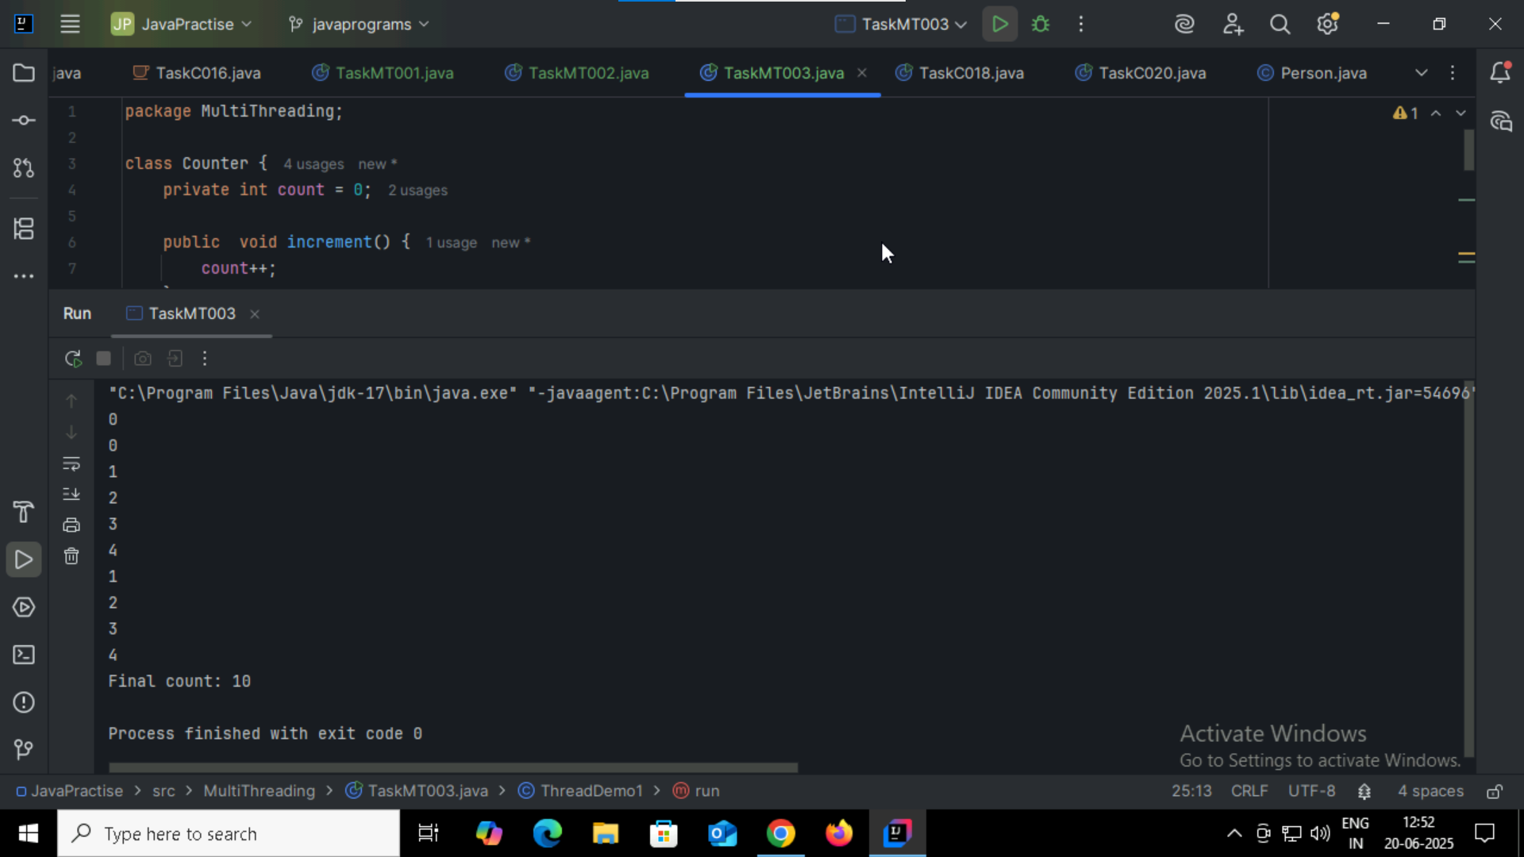

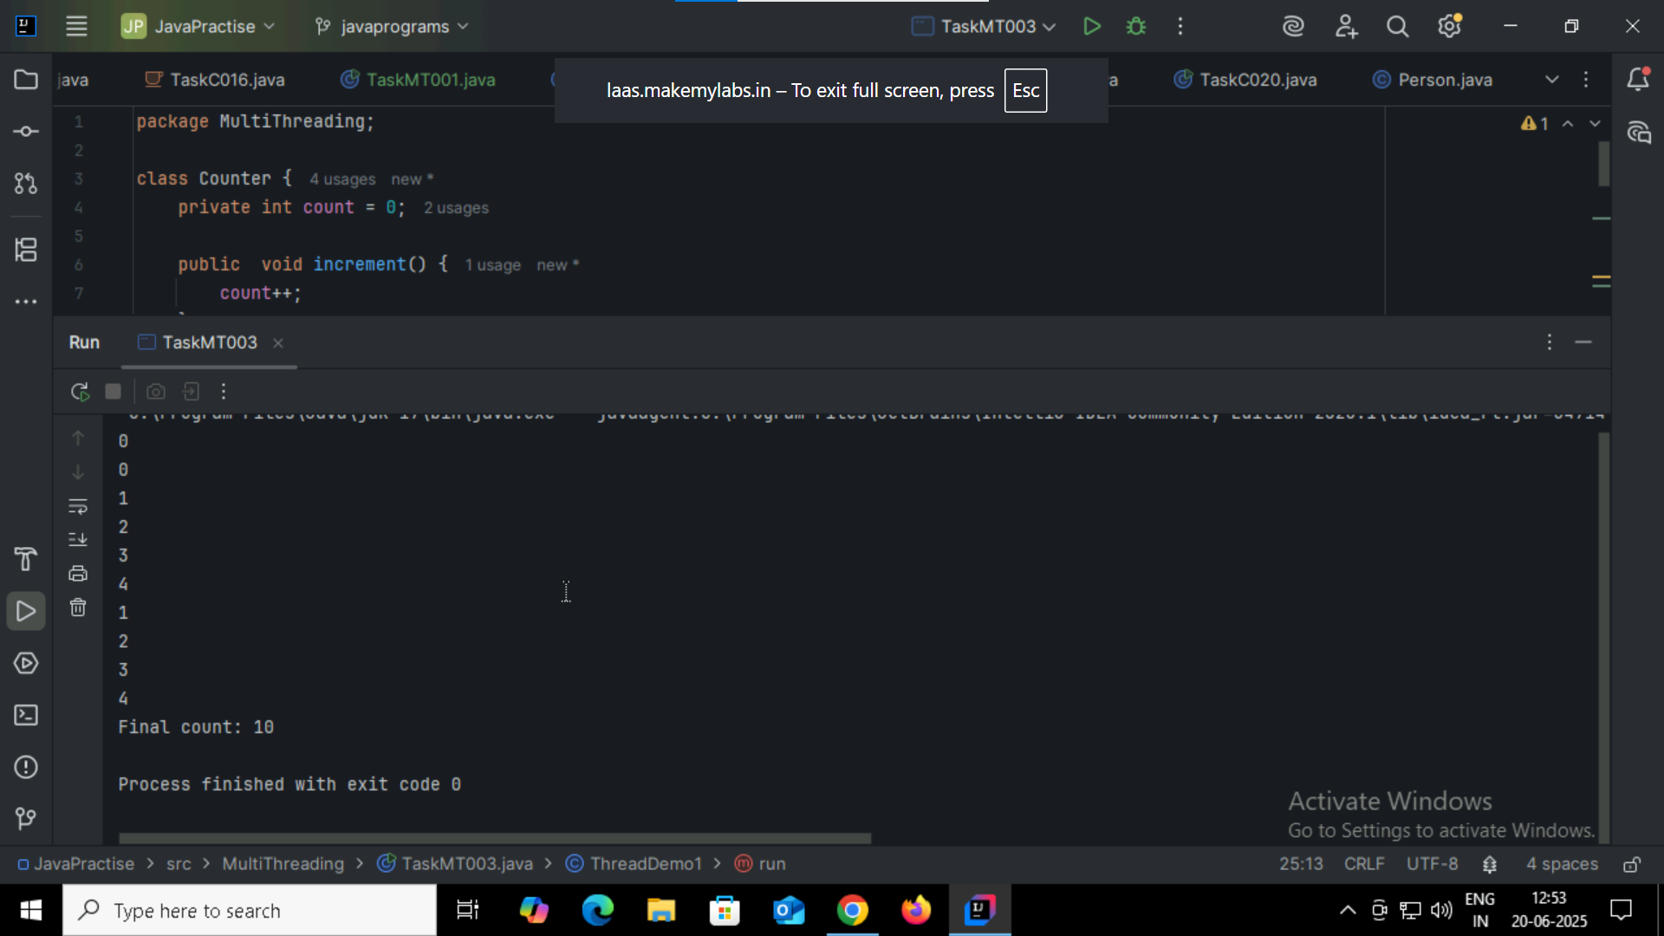

Task006: synchronized

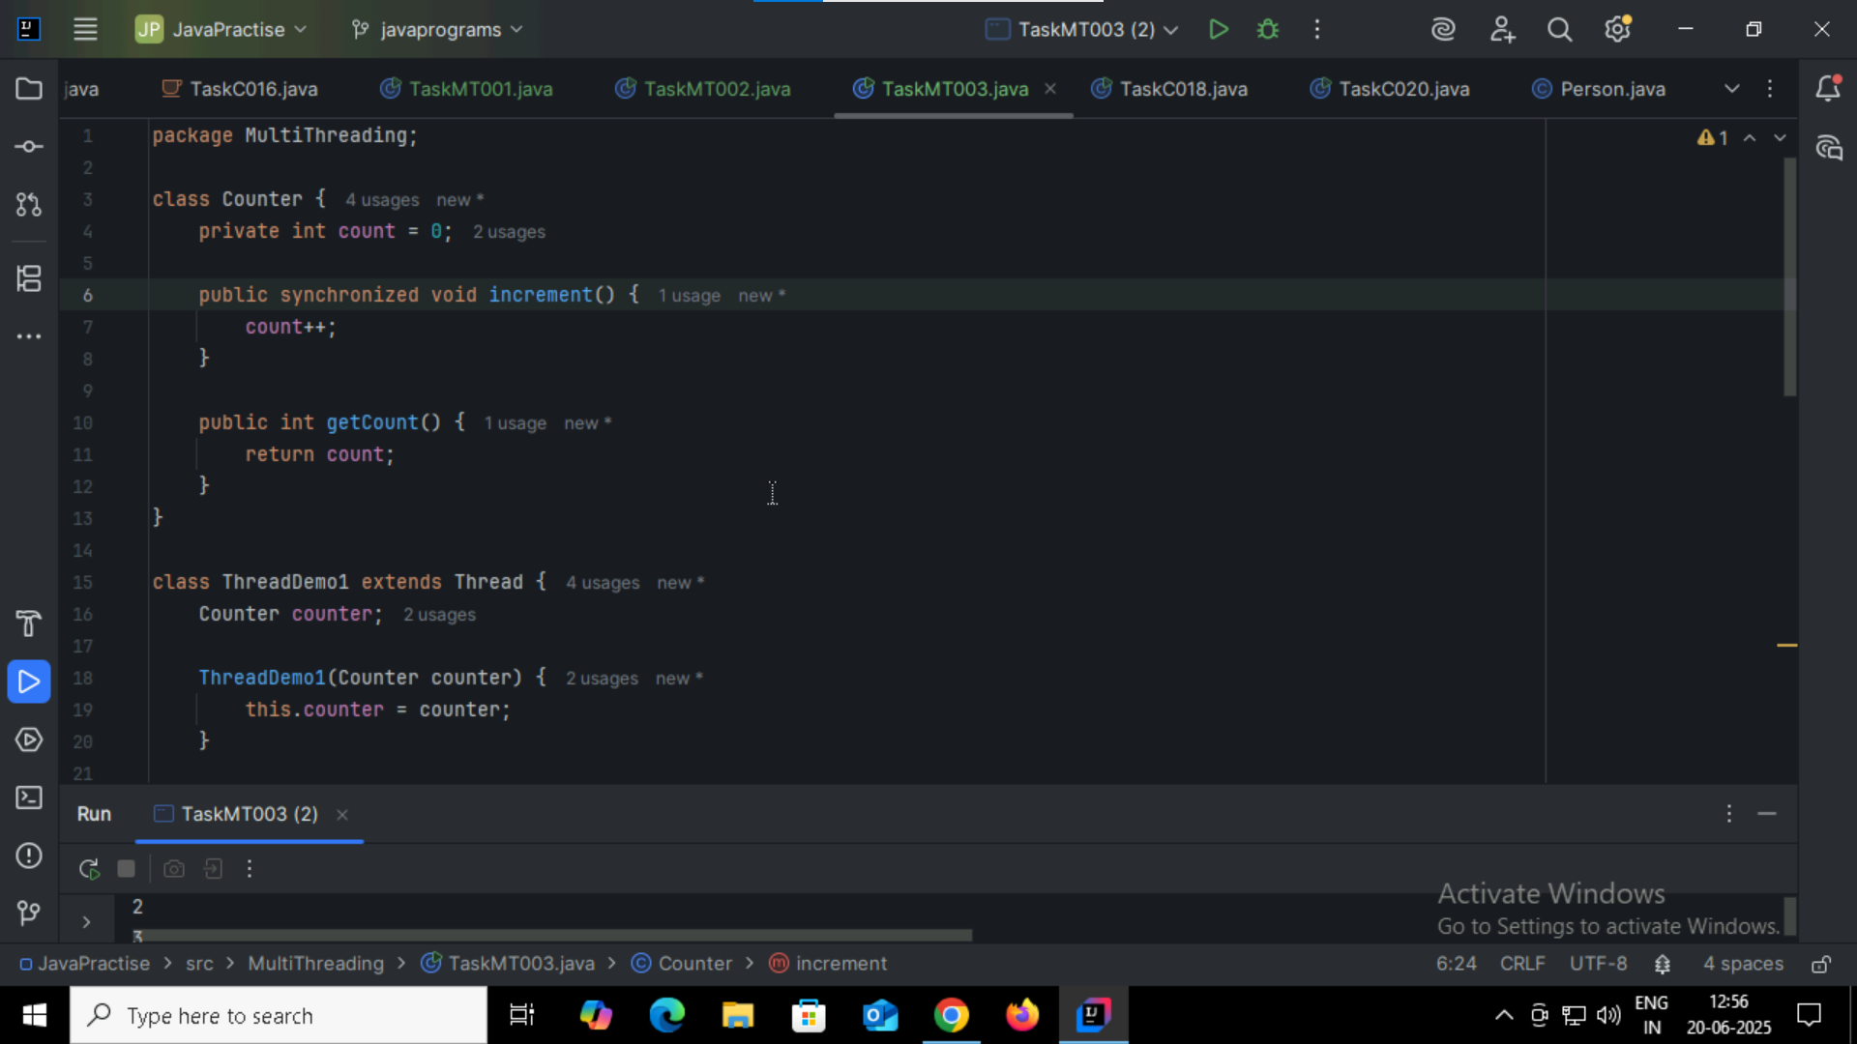

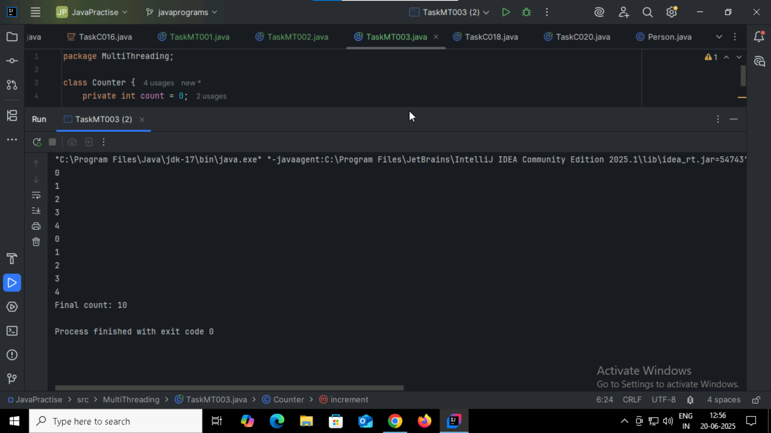

Task007:synchronized(this)

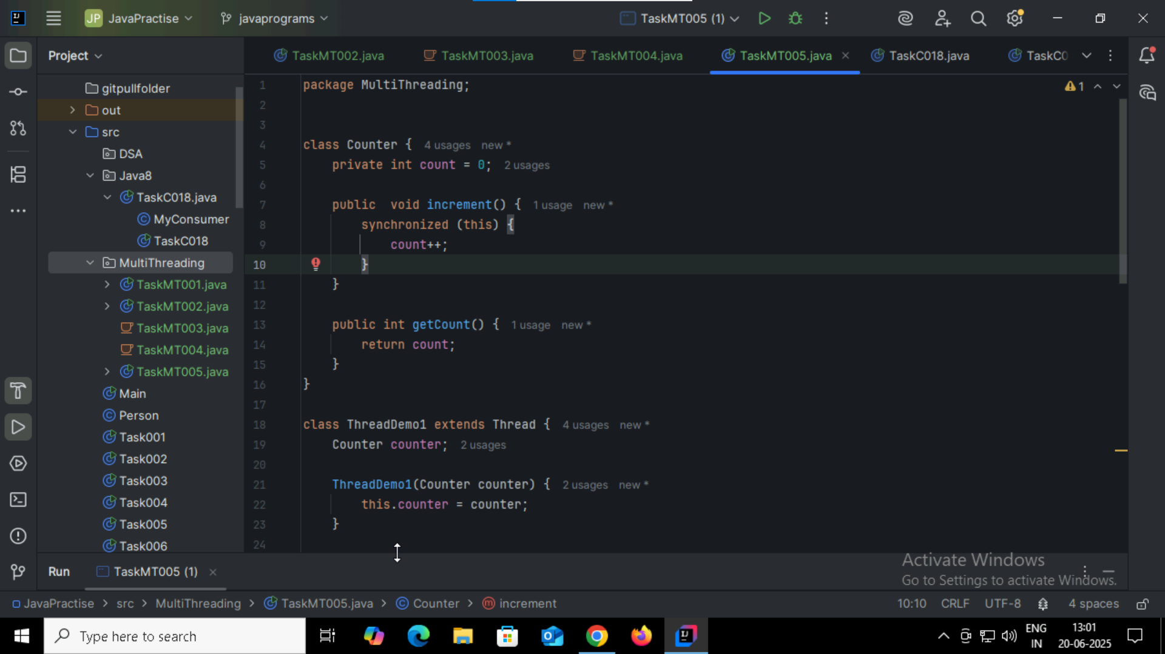

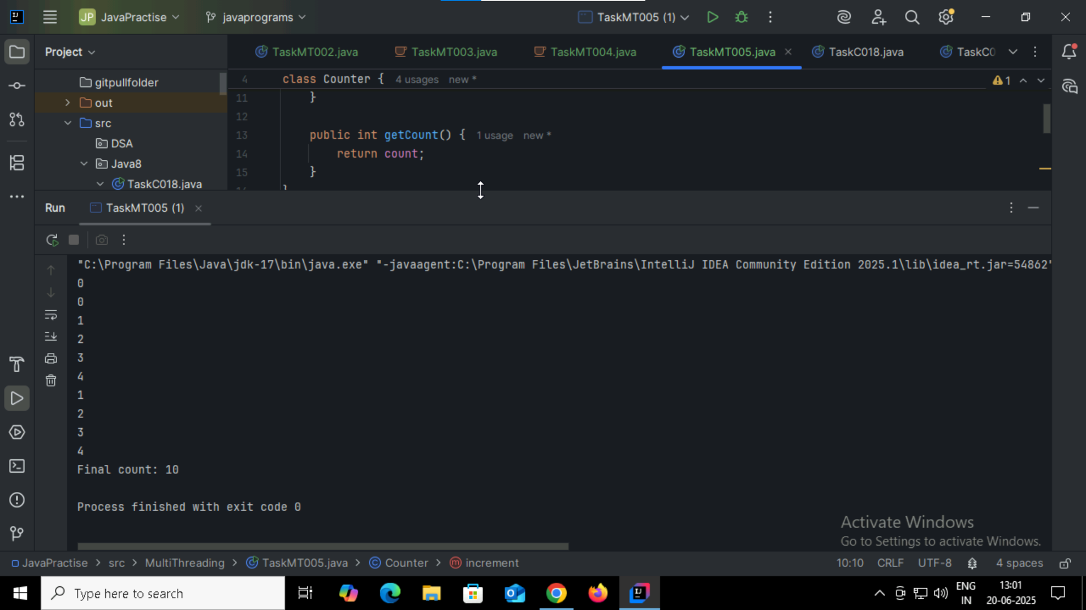

Task008: showing error

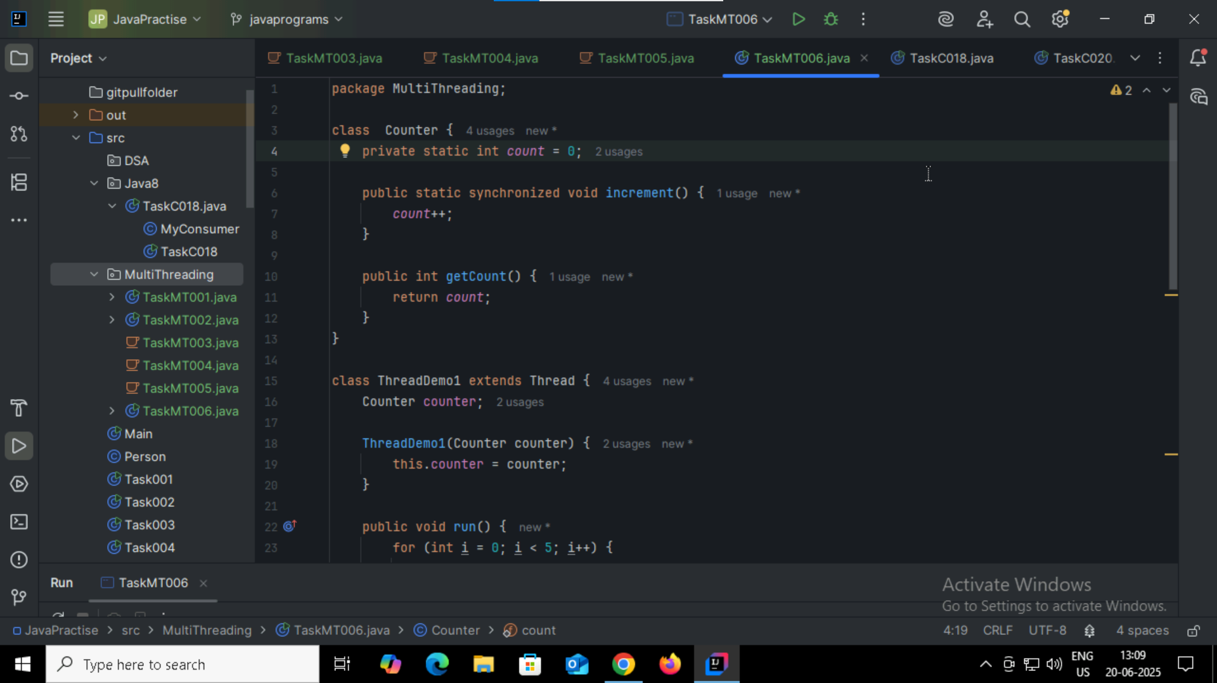

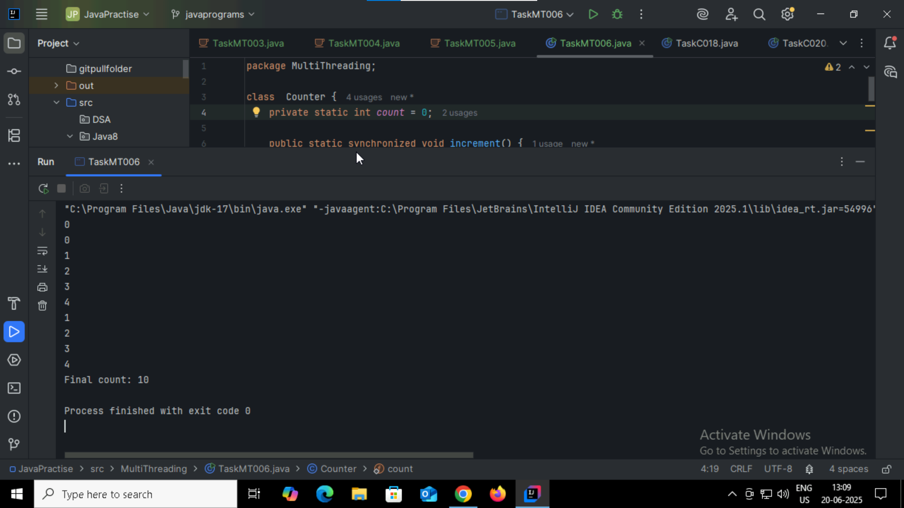

Task009:

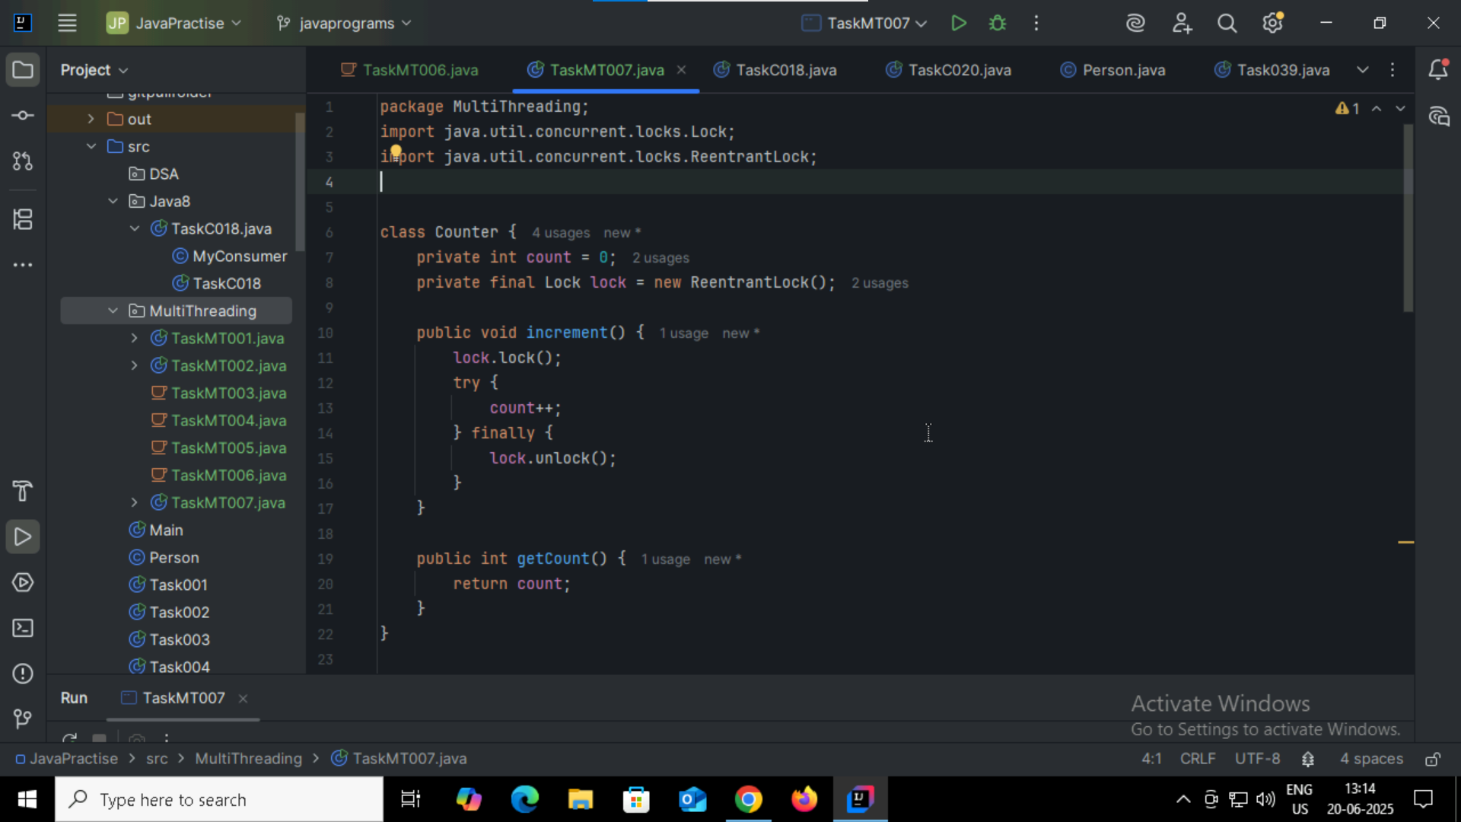

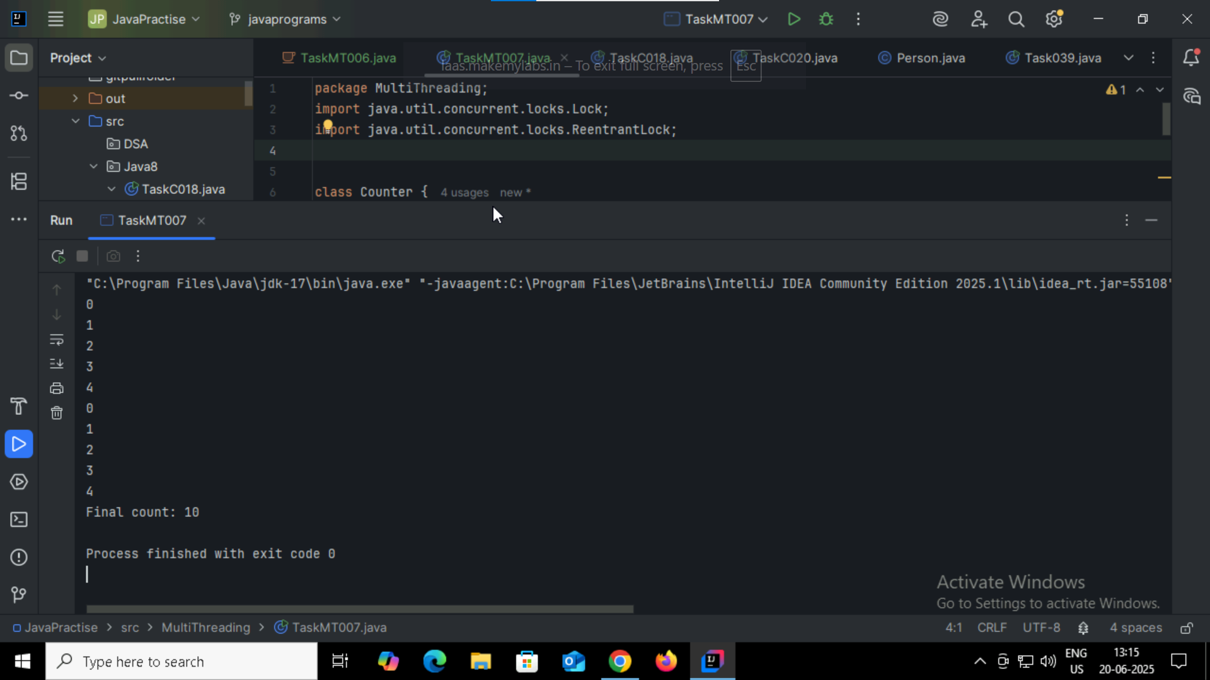

Task010:

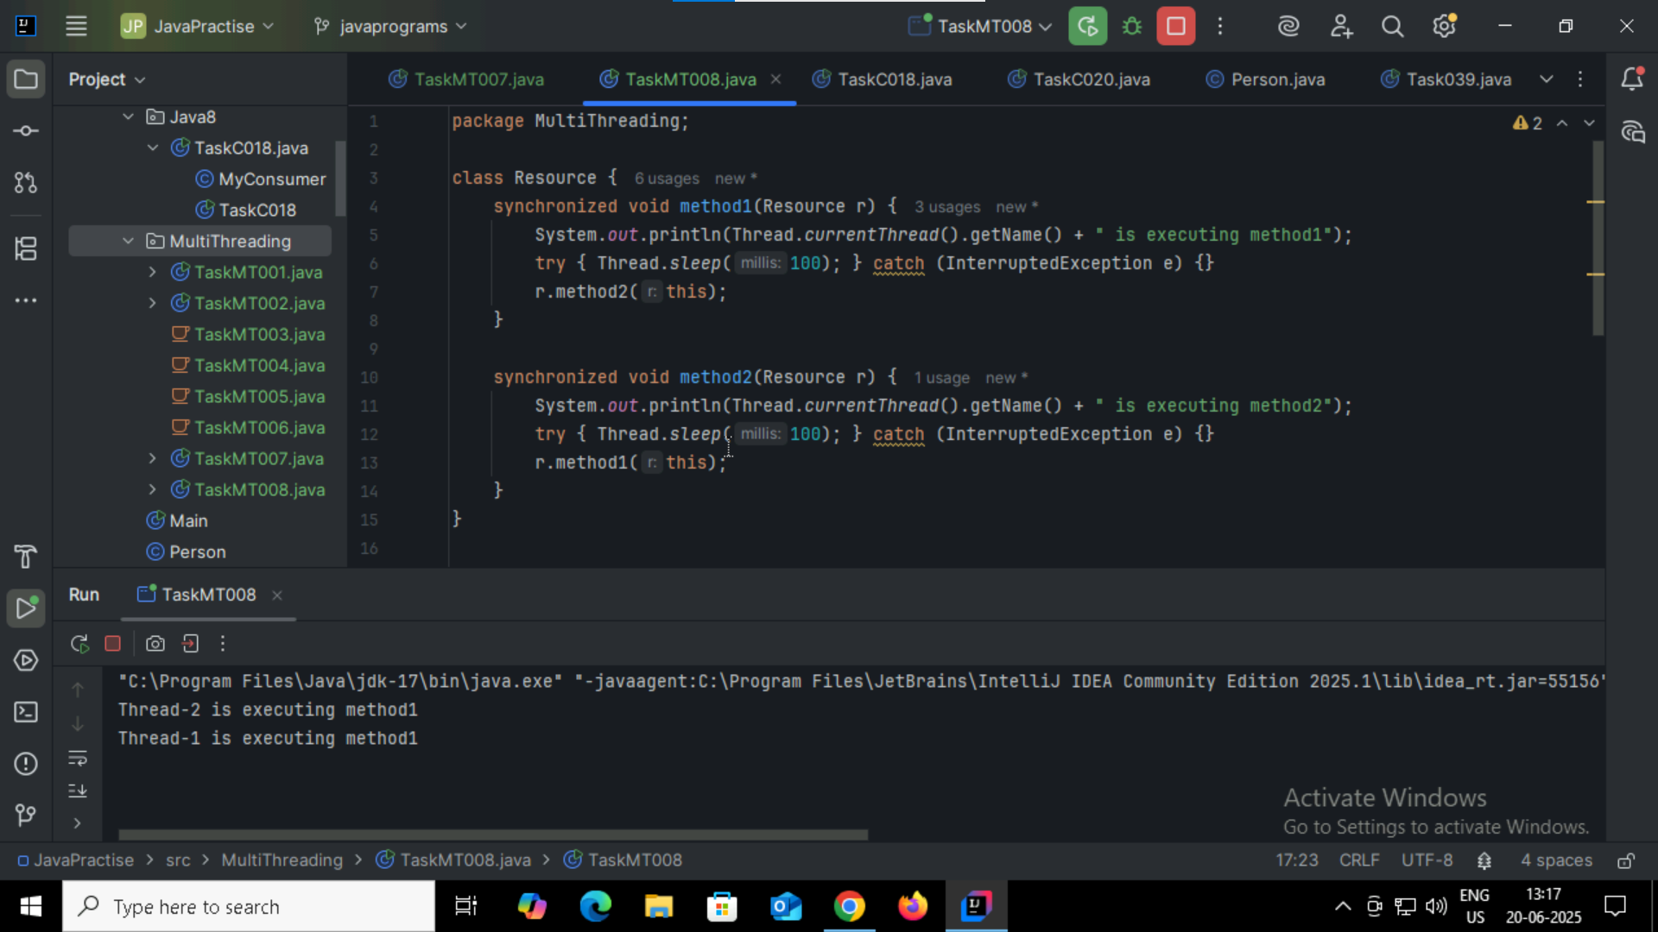

Task011:

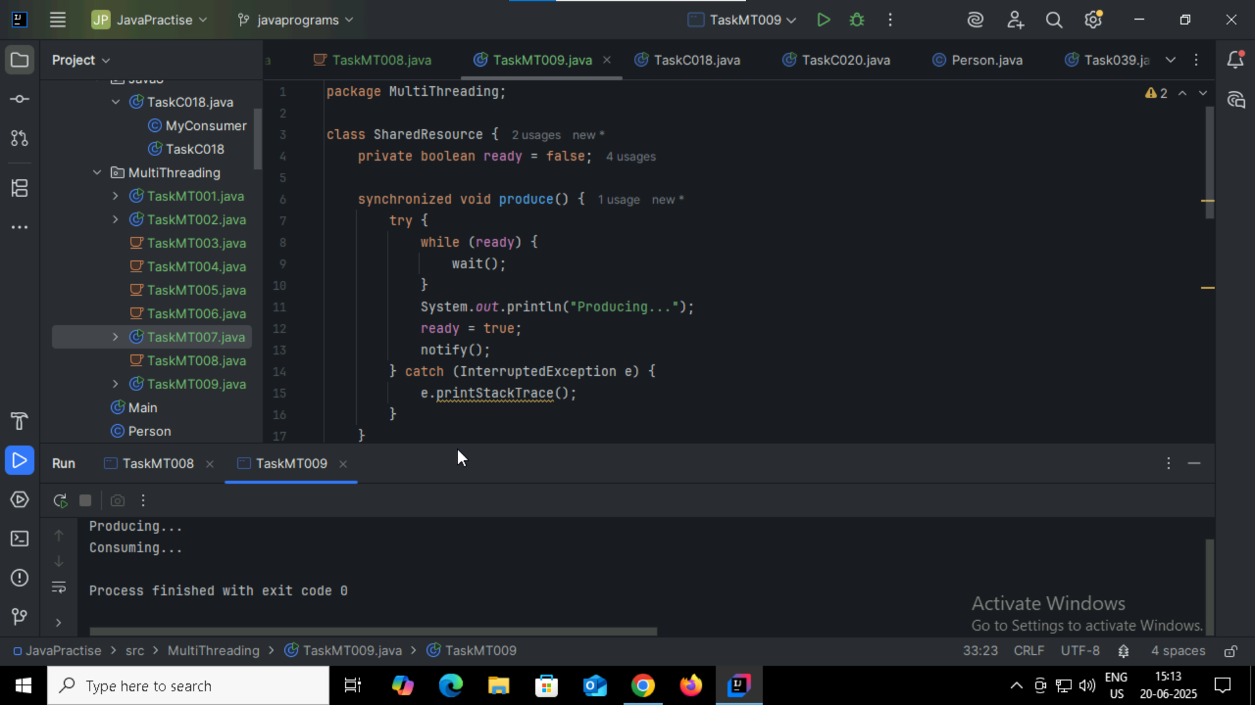

Task012:

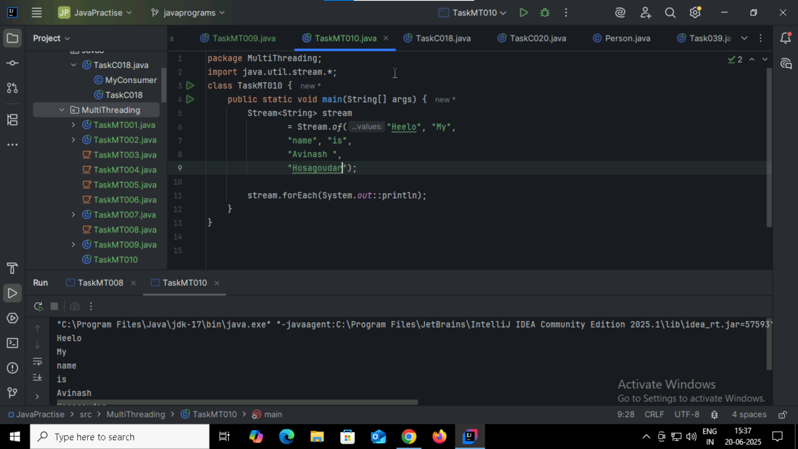

Task013:

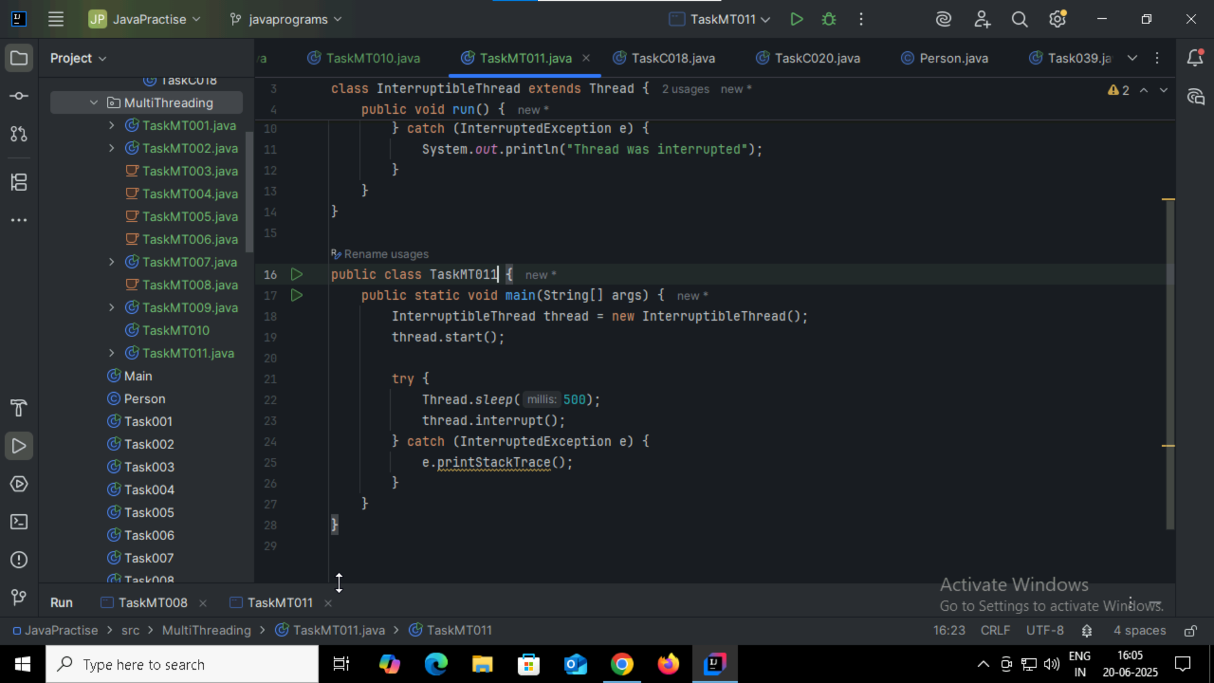

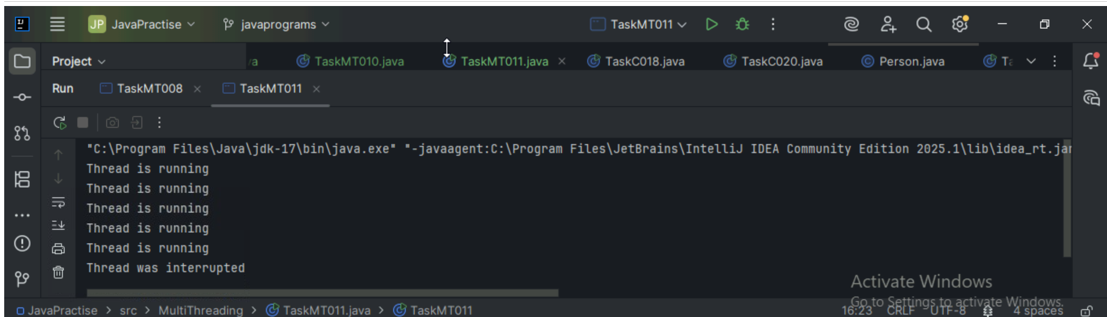

Task014:

What are Daemon threads? Explain…  
this is background thread that runs behind the scenes to support main task of the program, once main program or thread is end its execution it will also stop .

Task015:

What are the debugging tools list them:

Eclipse Jprofiler

Intellij JConsole

Eclipse VisualVM

Task016:

Try to understand the error Messages.. What are they and when to you?

Few are given below.

Error Messages in Java

Compile time and run time

**Compile time :**  grammatical mistakes … ;, {} , missing the code

**Run time error or exceptions**

Stack overflow error - it will occur when program uses too much stack memory

Array index out of bounds

IO exception --- when user wants to fetch the data out from the array size or value

Nulpointer exception when program tries to use an object refernce that is null

Task017:

What is Stack trace.. What will it do?

It is a report of the active stack frames at a certain point in time during the execution of program specially when exception occurs.  
it shows where error happened , and how program got there , line by line through method calls

Understand the below points..

Identify the error

Locate the code

Analyze the code

Solution also

Task018:

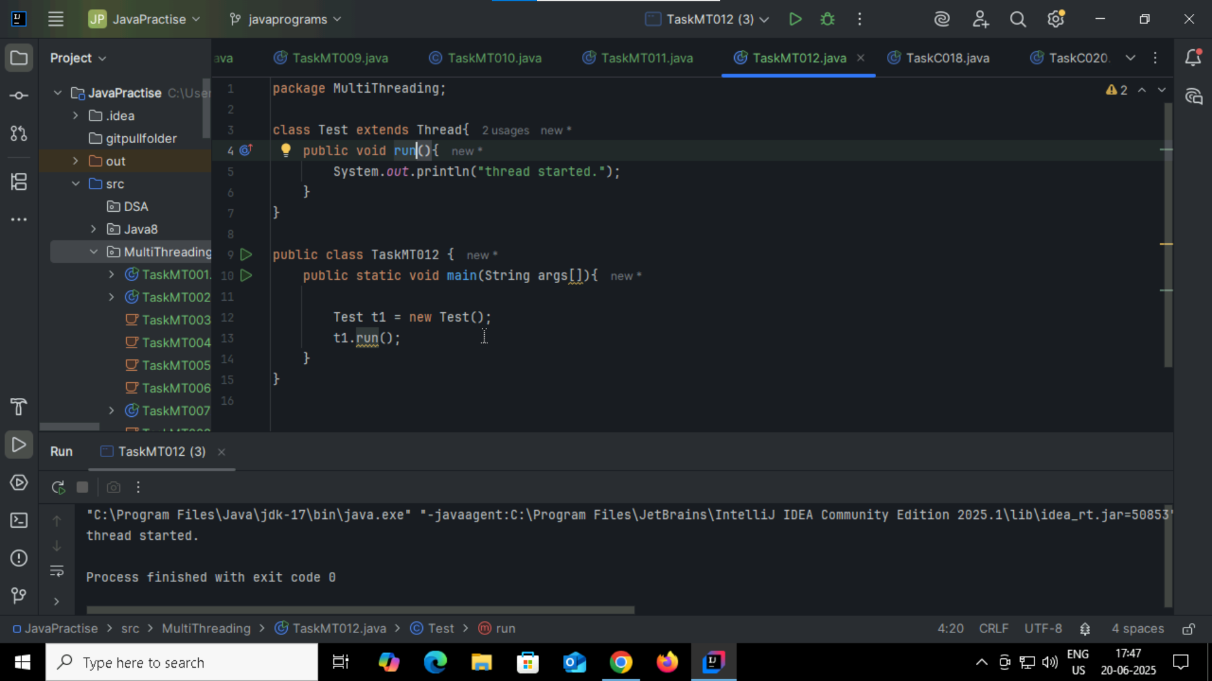

Task019:

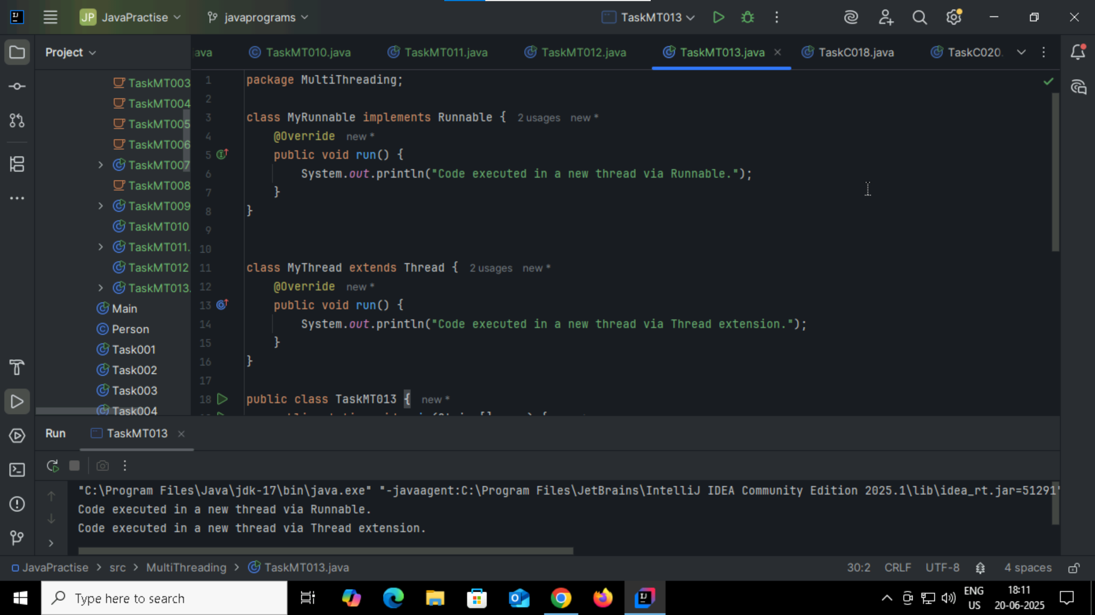

Task20:

